**Project 3 Report**

D11315807

Ardiawan Bagus Harisa

Department of CSIE

**Exercise 2**

1. Create a triangle using VBO + VAO.
2. When the mouse is moved, use its (x, y) position to change the color of one of the triangle’s vertices.
3. Update that vertex’s color data in the VBO using glBufferSubData() every frame.

**How to use my program:**

1. First, you must have the freeglut and glew library installed.
2. For my convenience, I use VS Studio for debugging.
3. Just run the debug by pressing **F5**. You will get the following result:

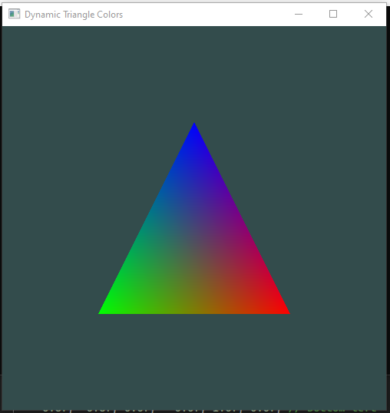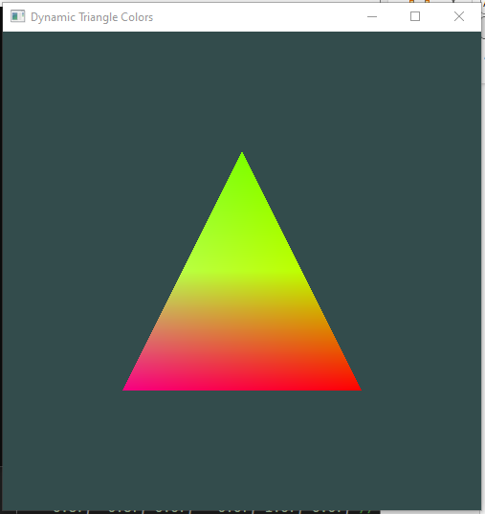

**Program:**

1. **Create Triangle**

Declares the shader object, VAO, and VBO, and the vertices (make it global here because we will need it to change the triangle’s color).

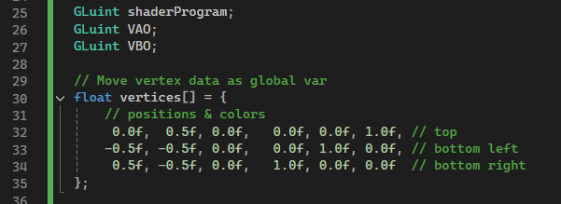

1. **Detect mouse position, use to change color**

After I can detect the mouse event (position), I used that information to update the color of each vertex according to my rule. Because the screen Y is the opposite of the OpenGL coordinate system, we must use 1 - y value. So it is kind of mechanism to normalize the screen device coordinate.

In the loop of vertices,

* Each vertices data store the position and the color (x,y,z,r,g,b). So that’s why the base offset is 3 + i*6 (floats) in total.
* For each line of vertices, the color will be calculated as shown in the comment.

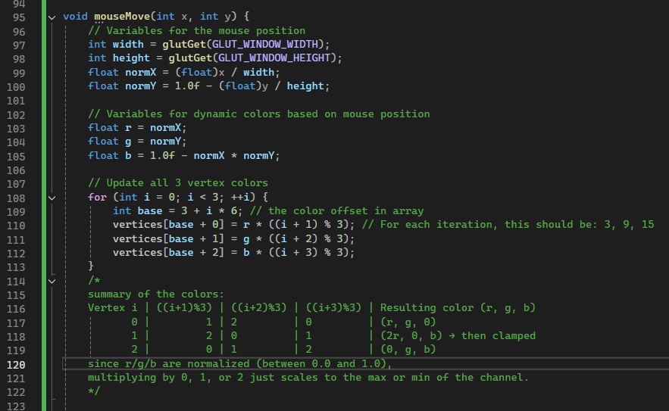

1. **Update vertex color data in VBO using glBufferSubData()**

Create the vertex shader and fragment shader.

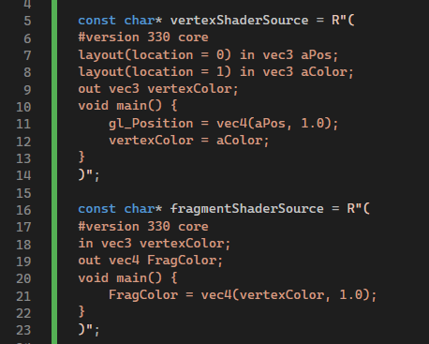

Similar to the previous project’s method, I tried to compile the vertex shader and the fragment shader. Then tried to attach them to the shader program. Also, delete the shader because it is not needed as a standalone program.

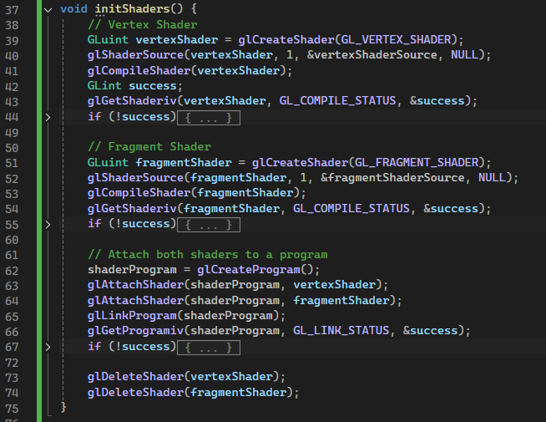

Similarly to the project 3 and 4, initialize our buffers: VAO and VBO. Here, the difference is the GL_DYNAMIC_DRAW, because we want to change the triangle’s color dynamically (the vertex data will change a lot.

Line 86 means, we use parameters of location 0 (pos in vertex shader)🡪 3 float (x,y,z), interval at 6 floats (3 positions and 3 colors) at the offset 0. While the line 88 means, the generally same idea but start after the first index, index = 1 (color), with the offset = 3xsize of float.

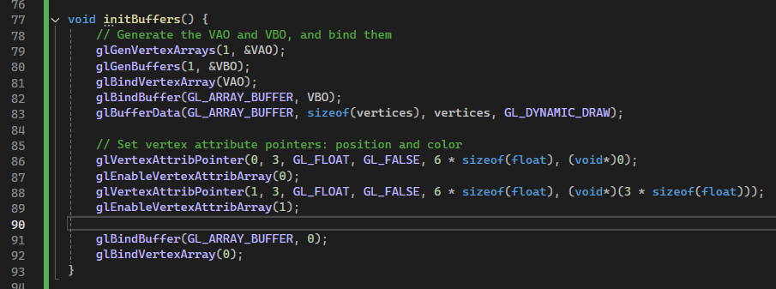

Just call the drawing function in the display. Then, call display into the main function. And run it.

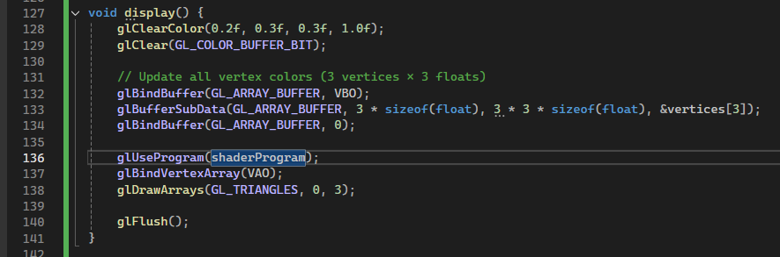

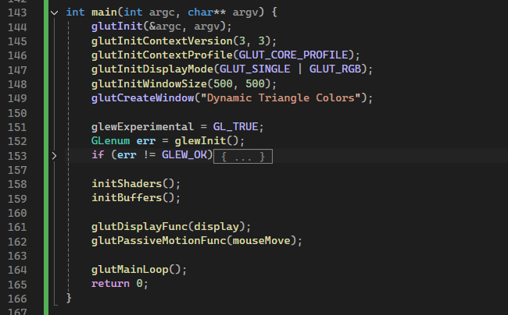

**Results:**

** **

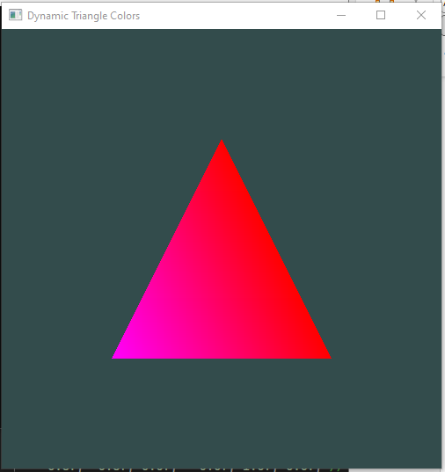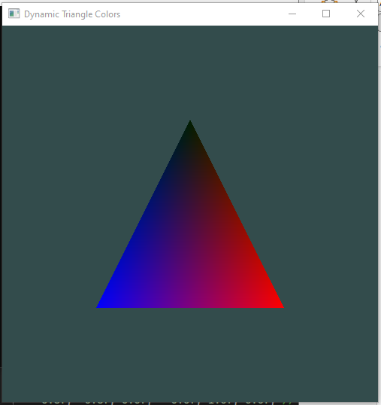

**Source code:**

x

#include <GL/glew.h>

#include <GL/freeglut.h>

#include <iostream>

const char* vertexShaderSource = R"(

#version 330 core

layout(location = 0) in vec3 aPos;

layout(location = 1) in vec3 aColor;

out vec3 vertexColor;

void main() {

gl_Position = vec4(aPos, 1.0);

vertexColor = aColor;

}

)";

const char* fragmentShaderSource = R"(

#version 330 core

in vec3 vertexColor;

out vec4 FragColor;

void main() {

FragColor = vec4(vertexColor, 1.0);

}

)";

GLuint shaderProgram;

GLuint VAO;

GLuint VBO;

// Move vertex data as global var

float vertices[] = {

// positions & colors

0.0f, 0.5f, 0.0f, 0.0f, 0.0f, 1.0f, // top

-0.5f, -0.5f, 0.0f, 0.0f, 1.0f, 0.0f, // bottom left

0.5f, -0.5f, 0.0f, 1.0f, 0.0f, 0.0f // bottom right

};

void initShaders() {

// Vertex Shader

GLuint vertexShader = glCreateShader(GL_VERTEX_SHADER);

glShaderSource(vertexShader, 1, &vertexShaderSource, NULL);

glCompileShader(vertexShader);

GLint success;

glGetShaderiv(vertexShader, GL_COMPILE_STATUS, &success);

if (!success) {

char infoLog[512];

glGetShaderInfoLog(vertexShader, 512, NULL, infoLog);

std::cerr << "Failed to compile vertex shader\n" << infoLog << std::endl;

}

// Fragment Shader

GLuint fragmentShader = glCreateShader(GL_FRAGMENT_SHADER);

glShaderSource(fragmentShader, 1, &fragmentShaderSource, NULL);

glCompileShader(fragmentShader);

glGetShaderiv(fragmentShader, GL_COMPILE_STATUS, &success);

if (!success) {

char infoLog[512];

glGetShaderInfoLog(fragmentShader, 512, NULL, infoLog);

std::cerr << "Failed to compile fragment shader\n" << infoLog << std::endl;

}

// Attach both shaders to a program

shaderProgram = glCreateProgram();

glAttachShader(shaderProgram, vertexShader);

glAttachShader(shaderProgram, fragmentShader);

glLinkProgram(shaderProgram);

glGetProgramiv(shaderProgram, GL_LINK_STATUS, &success);

if (!success) {

char infoLog[512];

glGetProgramInfoLog(shaderProgram, 512, NULL, infoLog);

std::cerr << "Failed to link shaders\n" << infoLog << std::endl;

}

glDeleteShader(vertexShader);

glDeleteShader(fragmentShader);

}

void initBuffers() {

// Generate the VAO and VBO, and bind them

glGenVertexArrays(1, &VAO);

glGenBuffers(1, &VBO);

glBindVertexArray(VAO);

glBindBuffer(GL_ARRAY_BUFFER, VBO);

glBufferData(GL_ARRAY_BUFFER, sizeof(vertices), vertices, GL_DYNAMIC_DRAW);

// Set vertex attribute pointers: position and color

glVertexAttribPointer(0, 3, GL_FLOAT, GL_FALSE, 6 * sizeof(float), (void*)0);

glEnableVertexAttribArray(0);

glVertexAttribPointer(1, 3, GL_FLOAT, GL_FALSE, 6 * sizeof(float), (void*)(3 * sizeof(float)));

glEnableVertexAttribArray(1);

glBindBuffer(GL_ARRAY_BUFFER, 0);

glBindVertexArray(0);

}

void mouseMove(int x, int y) {

// Variables for the mouse position

int width = glutGet(GLUT_WINDOW_WIDTH);

int height = glutGet(GLUT_WINDOW_HEIGHT);

float normX = (float)x / width;

float normY = 1.0f - (float)y / height;

// Variables for dynamic colors based on mouse position

float r = normX;

float g = normY;

float b = 1.0f - normX * normY;

// Update all 3 vertex colors

for (int i = 0; i < 3; ++i) {

int base = 3 + i * 6; // the color offset in array

vertices[base + 0] = r * ((i + 1) % 3); // For each iteration, this should be: 3, 9, 15

vertices[base + 1] = g * ((i + 2) % 3);

vertices[base + 2] = b * ((i + 3) % 3);

}

/*

summary of the colors:

Vertex i | ((i+1)%3) | ((i+2)%3) | ((i+3)%3) | Resulting color (r, g, b)

0 | 1 | 2 | 0 | (r, g, 0)

1 | 2 | 0 | 1 | (2r, 0, b) → then clamped

2 | 0 | 1 | 2 | (0, g, b)

since r/g/b are normalized (between 0.0 and 1.0),

multiplying by 0, 1, or 2 just scales to the max or min of the channel.

*/

glutPostRedisplay();

}

void display() {

glClearColor(0.2f, 0.3f, 0.3f, 1.0f);

glClear(GL_COLOR_BUFFER_BIT);

// Update all vertex colors (3 vertices × 3 floats)

glBindBuffer(GL_ARRAY_BUFFER, VBO);

glBufferSubData(GL_ARRAY_BUFFER, 3 * sizeof(float), 3 * 3 * sizeof(float), &vertices[3]);

glBindBuffer(GL_ARRAY_BUFFER, 0);

glUseProgram(shaderProgram);

glBindVertexArray(VAO);

glDrawArrays(GL_TRIANGLES, 0, 3);

glFlush();

}

int main(int argc, char** argv) {

glutInit(&argc, argv);

glutInitContextVersion(3, 3);

glutInitContextProfile(GLUT_CORE_PROFILE);

glutInitDisplayMode(GLUT_SINGLE | GLUT_RGB);

glutInitWindowSize(500, 500);

glutCreateWindow("Dynamic Triangle Colors");

glewExperimental = GL_TRUE;

GLenum err = glewInit();

if (err != GLEW_OK) {

std::cerr << "GLEW Error: " << glewGetErrorString(err) << std::endl;

return -1;

}

initShaders();

initBuffers();

glutDisplayFunc(display);

glutPassiveMotionFunc(mouseMove);

glutMainLoop();

return 0;

}